## Objective: AVR Microcontroller LCD Programming In C.

**Task-1:-**  Interface 16x2 LCD with ATMEGA32 in 8-bit mode. Write a program to display your name. Your first name should be displayed from the 5th position of the 1st ROW and your surname from the 3rd position of the 2nd row.

**Code:-**

#include <avr/io.h>

#include <util/delay.h>

#define F_CPU 1000000UL

void LCD_Command(unsigned char Command) {

PORTB = Command;

PORTC &= ~(0x01);

PORTC &= ~(0x02);

PORTC |= (0x04);

_delay_ms(1); // Increased delay for commands

PORTC &= ~(0x04);

}

void LCD_Data(unsigned char Data) {

PORTB = Data;

PORTC |= (0x01);

PORTC &= ~(0x02);

PORTC |= (0x04);

_delay_ms(1); // Increased delay for data

PORTC &= ~(0x04);

}

void LCD_Init() {

_delay_ms(50); // wait for LCD to power up

LCD_Command(0x38); // Initialize 8-bit mode

LCD_Command(0x0C); // Display ON, Cursor OFF

LCD_Command(0x06); // Increment cursor

LCD_Command(0x01); // Clear LCD

_delay_ms(2); // Delay for LCD to clear

LCD_Command(0x80); // Move cursor to beginning of first line

}

void LCD_SetCursor(uint8_t row, uint8_t column) {

uint8_t position = 0x80; // Base address for the first line

if (row == 1) // If second row

position = 0xC0; // Base address for the second line

position += column - 1; // Adjust position for the desired column

LCD_Command(position); // Set cursor position

}

int main(void) {

DDRB = 0xFF;

DDRC = 0xFF;

LCD_Init();

char First_Name[5] = "ARYAN";

char Last_Name[10] = "LANGHANOJA";

LCD_SetCursor(0, 5);

for (int i = 0; i < 5; i++) {

LCD_Data(First_Name[i]);

}

LCD_SetCursor(1, 3);

for (int i = 0; i < 10; i++) {

LCD_Data(Last_Name[i]);

}

while (1);

return 0;

}

**Circuit:-**

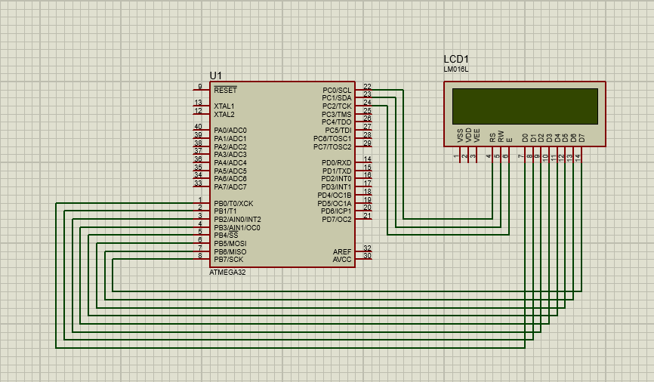

**Task-2 :-**  Interface 16x2 LCD with ATMEGA32 in 4-bit mode to do the same task as mentioned in problem 1.

**Code :-**

#include <avr/io.h>

#include <util/delay.h>

#define F_CPU 1000000UL

void LCD_Command(unsigned char Command) {

unsigned char A , B ;

A = Command & 0xF0 ;

PORTB = A | 0x04 ;

_delay_ms(100);

PORTB &= ~(0x04) ;

B = Command << 4 ;

PORTB = B | 0x04 ;

_delay_ms(100) ;

PORTB &= ~(0x04) ;

}

void LCD_Data(unsigned char Data) {

unsigned char A,B ;

A = Data & 0xF0 ;

PORTB = 0x05 | A ;

_delay_ms(100) ;

PORTB &= ~(0x04) ;

B = Data << 4 ;

PORTB = 0x05 | B ;

_delay_ms(100) ;

PORTB &= ~(0x04) ;

}

void LCD_SetCursor(uint8_t row, uint8_t column) {

uint8_t position = 0x80;

if (row == 1)

position = 0xC0;

position += column - 1;

LCD_Command(position);

}

int main(void) {

DDRB = 0x0F ;

LCD_Command(0x02);

LCD_Command(0x28);

LCD_Command(0x0E);

LCD_Command(0x06);

LCD_Command(0x01);

LCD_Command(0x80);

char First_Name[5] = "ARYAN";

char Last_Name[10] = "LANGHANOJA";

LCD_SetCursor(0, 5);

for (int i = 0; i < 5; i++) {

LCD_Data(First_Name[i]);

}

LCD_SetCursor(1, 3);

for (int i = 0; i < 10; i++) {

LCD_Data(Last_Name[i]);

}

while (1);

return 0;

}

**Circuit:-**

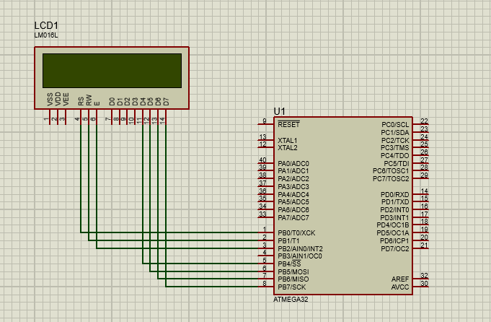

**Task-3 :-**   Write a program to display scrolling text in 16x2 LCD. Assume the string to displayed as per your choice.

**Code :-**

#include <avr/io.h>

#include <util/delay.h>

#define LCD_DATA_PORT PORTD

#define LCD_CTRL_PORT PORTC

#define LCD_RS PC0

#define LCD_RW PC1

#define LCD_EN PC2

void LCD_Command(unsigned char Command) {

LCD_DATA_PORT = (LCD_DATA_PORT & 0x0F) | (Command & 0xF0);

LCD_CTRL_PORT &= ~(1 << LCD_RS); // RS low for command

LCD_CTRL_PORT &= ~(1 << LCD_RW); // RW low for write

LCD_CTRL_PORT |= (1 << LCD_EN); // Enable high

_delay_us(1);

LCD_CTRL_PORT &= ~(1 << LCD_EN); // Enable low

_delay_us(100);

LCD_DATA_PORT = (LCD_DATA_PORT & 0x0F) | ((Command << 4) & 0xF0);

LCD_CTRL_PORT |= (1 << LCD_EN); // Enable high

_delay_us(1);

LCD_CTRL_PORT &= ~(1 << LCD_EN); // Enable low

_delay_ms(2);

}

void LCD_Data(unsigned char Data) {

LCD_DATA_PORT = (LCD_DATA_PORT & 0x0F) | (Data & 0xF0);

LCD_CTRL_PORT |= (1 << LCD_RS); // RS high for data

LCD_CTRL_PORT &= ~(1 << LCD_RW); // RW low for write

LCD_CTRL_PORT |= (1 << LCD_EN); // Enable high

_delay_us(1);

LCD_CTRL_PORT &= ~(1 << LCD_EN); // Enable low

_delay_us(100);

LCD_DATA_PORT = (LCD_DATA_PORT & 0x0F) | ((Data << 4) & 0xF0);

LCD_CTRL_PORT |= (1 << LCD_EN); // Enable high

_delay_us(1);

LCD_CTRL_PORT &= ~(1 << LCD_EN); // Enable low

_delay_ms(2);

}

void LCD_Init(void) {

LCD_DATA_PORT = 0xFF; // Initialize LCD data port as output

LCD_CTRL_PORT |= (1 << LCD_EN) | (1 << LCD_RW) | (1 << LCD_RS); // Initialize control port pins as output

_delay_ms(20);

LCD_Command(0x33); // Initialization sequence

LCD_Command(0x32); // Initialization sequence

LCD_Command(0x28); // 4-bit mode, 2 lines, 5x8 font

LCD_Command(0x0C); // Display on, cursor off, blink off

LCD_Command(0x06); // Increment cursor

LCD_Command(0x01); // Clear display

_delay_ms(2);

}

void LCD_Clear(void) {

LCD_Command(0x01); // Clear display

_delay_ms(2);

}

void LCD_GotoXY(unsigned char x, unsigned char y) {

unsigned char address = 0;

if (y == 0) {

address = 0x80 + x; // Line 1

} else if (y == 1) {

address = 0xC0 + x; // Line 2

}

LCD_Command(address);

}

void LCD_Puts(const char *str) {

while (*str) {

LCD_Data(*str++);

}

}

// right to left

void LCD_Scroll_Text(const char *text) {

int len = 0;

while (text[len] != '\0') {

len++;

}

// Calculate the starting position

int start_position = len > 16 ? len - 16 : 0;

// Add spaces at the beginning to adjust the starting position

char scrolled_text[2 * len + 6]; // Double the length of the text for scrolling effect

for (int i = 0; i < start_position; i++) {

scrolled_text[i] = ' ';

}

// Copy the text to scrolled_text

for (int i = 0; i < len; i++) {

scrolled_text[start_position + i] = text[i];

}

while (1) {

for (int i = 0; i < len + start_position + 3; i++) {

LCD_Clear();

LCD_GotoXY(0, 0);

LCD_Puts(scrolled_text + i);

_delay_ms(500); // Adjust the delay as needed for desired scrolling speed

}

}

}

int main(void) {

DDRD = 0xFF; // Port D as output

DDRC |= (1 << LCD_EN) | (1 << LCD_RW) | (1 << LCD_RS); // Control pins as output

LCD_Init();

LCD_Clear();

LCD_Scroll_Text("HELLO FROM ARYAN LANGHANOJA");

while (1) {

}

return 0;

}

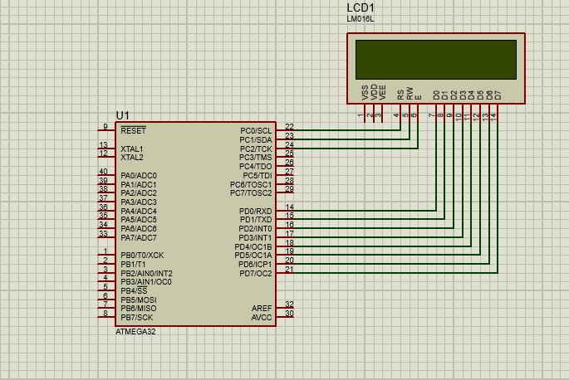**Circuit :-**

**Task-4 :-**  In continuation with problem 3, take an input from two switches connected on PD0 and PD1, and show the scrolling of text from right to left and left to right.

**Code :-**

#include <avr/io.h>

#include <util/delay.h>

#define LCD_DATA_PORT PORTD // Data port connected to PORT D

#define LCD_CTRL_PORT PORTC // Control port connected to PORT C

#define LCD_RS PC0 // Register select pin

#define LCD_EN PC1 // Enable pin

void lcd_command(unsigned char cmnd) {

LCD_DATA_PORT = cmnd;

LCD_CTRL_PORT &= ~(1 << LCD_RS); // RS = 0 for command

LCD_CTRL_PORT |= (1 << LCD_EN); // EN = 1 for H-to-L pulse

_delay_us(1);

LCD_CTRL_PORT &= ~(1 << LCD_EN); // EN = 0 to latch command

_delay_us(100);

}

void lcd_data(unsigned char data) {

LCD_DATA_PORT = data;

LCD_CTRL_PORT |= (1 << LCD_RS); // RS = 1 for data

LCD_CTRL_PORT |= (1 << LCD_EN); // EN = 1 for H-to-L pulse

_delay_us(1);

LCD_CTRL_PORT &= ~(1 << LCD_EN); // EN = 0 to latch data

_delay_us(100);

}

void lcd_init() {

LCD_CTRL_PORT |= (1 << LCD_RS) | (1 << LCD_EN); // Set RS and EN as output

LCD_DATA_PORT = 0xFF; // Set data port as output

LCD_CTRL_PORT &= ~(1 << LCD_RS); // RS = 0 for command

LCD_CTRL_PORT &= ~(1 << LCD_EN); // EN = 0

_delay_ms(20); // Initialization routine

lcd_command(0x38); // 2 line, 5x8 matrix

lcd_command(0x0E); // Display on, cursor blinking

lcd_command(0x01); // Clear LCD

_delay_ms(2);

}

void lcd_string(char *str) {

while (*str)

lcd_data(*str++);

}

void lcd_scroll_left(char *str) {

int i, len;

len = strlen(str);

for (i = 0; i < len; i++) {

lcd_command(0x1C); // Shift display left

_delay_ms(500);

}

}

void lcd_scroll_right(char *str) {

int i, len;

len = strlen(str);

for (i = 0; i < len; i++) {

lcd_command(0x18); // Shift display right

_delay_ms(500);

}

}

int main() {

DDRB &= ~(1 << DDB0) & ~(1 << DDB1); // Set PB0 and PB1 as input

PORTB |= (1 << PB0) | (1 << PB1); // Enable pull-up resistors for PB0 and PB1

DDRD = 0xFF; // Set PORTD as output

DDRC = 0xFF; // Set PORTC as output

lcd_init();

char message[] = "Scrolling Text";

while (1) {

if (!(PINB & (1 << PB0))) {

// If PB0 is high, scroll text

lcd_scroll_left(message);

} else if (!(PINB & (1 << PB1))) {

// If PB1 is high, scroll text in the opposite direction

lcd_scroll_right(message);

} else {

// If neither PB0 nor PB1 is high, display static text

lcd_command(0x01); // Clear LCD

lcd_command(0x80); // Set cursor to the beginning of the first line

lcd_string(message);

}

}

return 0;

}

**Circuit :-**

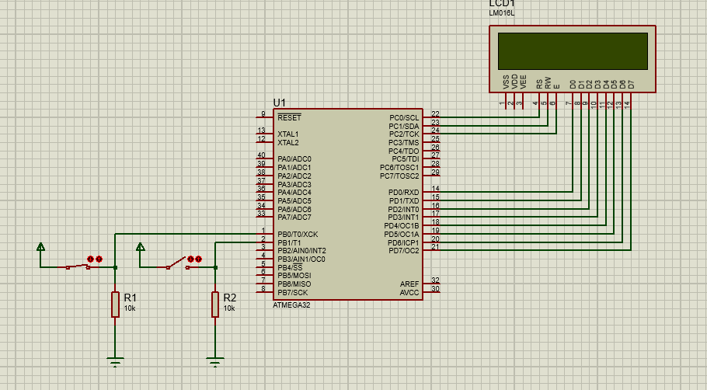

**Task-5 :-**  Display the coustom characters of your choice using 16x2 LCD and ATMEGA32.

**Code :-**

#define F_CPU 8000000UL

#include <avr/io.h>

#include <util/delay.h>

#define rs PB2

#define en PB3

void lcd_init();

void dis_cmd(char);

void dis_data(char);

void lcdcmd(char);

void lcddata(char);

void lcd_create_custom_char();

void lcd_display_custom_char();

int main(void)

{

DDRB = 0xFF;

lcd_init();

lcd_create_custom_char();

lcd_display_custom_char();

while (1)

{

// Your main code here

}

}

void lcd_init()

{

dis_cmd(0x02);

dis_cmd(0x28);

dis_cmd(0x01);

dis_cmd(0x0C);

dis_cmd(0x06);

dis_cmd(0x80); // Set DDRAM address to 0 (cursor at home position)

}

void dis_cmd(char cmd_value)

{

char cmd_value1;

cmd_value1 = cmd_value & 0xF0;

lcdcmd(cmd_value1);

cmd_value1 = ((cmd_value << 4) & 0xF0);

lcdcmd(cmd_value1);

}

void dis_data(char data_value)

{

char data_value1;

data_value1 = data_value & 0xF0;

lcddata(data_value1);

data_value1 = ((data_value << 4) & 0xF0);

lcddata(data_value1);

}

void lcdcmd(char cmdout)

{

PORTB = cmdout;

PORTB &= ~(1 << rs);

PORTB |= (1 << en);

_delay_ms(1);

PORTB &= ~(1 << en);

}

void lcddata(char dataout)

{

PORTB = dataout;

PORTB |= (1 << rs);

PORTB |= (1 << en);

_delay_ms(1);

PORTB &= ~(1 << en);

}

void lcd_create_custom_char()

{

// Set CGRAM address to 0

dis_cmd(0x40);

// Define custom character pattern (Heart shape)

dis_data(0b00000);

dis_data(0b01010);

dis_data(0b11111);

dis_data(0b11111);

dis_data(0b01110);

dis_data(0b00100);

dis_data(0b00000);

dis_data(0b00000);

// Set DDRAM address to 0x80 (cursor at home position)

dis_cmd(0x80);

_delay_ms(100);

}

void lcd_display_custom_char()

{

// Display the custom character at the beginning of the first line

dis_data(0); // Display custom character at position (0, 0)

}

**Circuit :-**